|  |  |  |  |
| --- | --- | --- | --- |
| C:\Users\abueso\AppData\Local\Microsoft\Windows\INetCache\Content.Word\LOGO_SOLARIZE (1).png | C:\Users\abueso\AppData\Local\Microsoft\Windows\INetCache\Content.Word\LOGO EU SOLARIS.PNG | C:\Users\abueso\AppData\Local\Microsoft\Windows\INetCache\Content.Word\logo_CIEMAT_compuesto.jpg |  |

**Abstract title here (Arial 14, Bold)**

Author or list of authors (Arial 11), presenting authors underlined.

*Author's affiliations (Arial 11, italic), including e-mail of presenting author. If different affiliations, use superscript to crosslink author1 and 1affiliation.*

Text of abstract **must not exceed 2 pages.**

It should be written in English in Arial 11, margins the same as this template. Abstracts should be submitted in **Word (DOCX Format)**.

The file should be named as “**Name.Surname EUSOLARIS-DC-2025**”.

Figures should have good resolution as they will appear in the electronic version of the EU-Solaris 2nd Doctoral Colloquium 2025 Book of Abstracts. They should be numbered as Fig.x, with a caption (Fig.x. Description of figure) below the figure with the same format and alignment as the example below. The figure must be referred and discussed in the text. The same applies for tables.

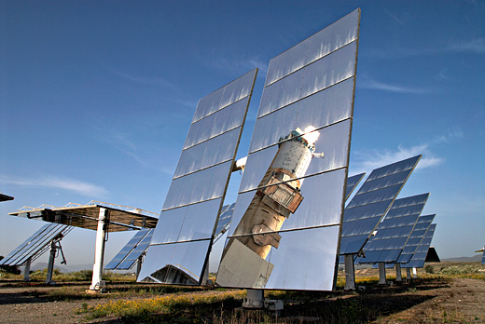

**Fig.1 (Arial 10, Bold underlined)**: Solar furnace of the Plataforma Solar de Almería facility in Tabernas (Spain). (Arial 10)

Any reference should be sequentially numbered in the text and cited as [1], [2] or [1,2]. References should be at the end of the abstract following the marked citing styles for:

Articles in journals **[1]** X. Author, Y. Author, Z. Author. ”Title”. Solar Energy, 262 (2020) 118-124.

Conference proceedings **[2]** X. Author, Y. Author, Z. Author. ”Title”. *Proc. of Congress, City,* Country, 2018, 24.

Books **[3]** *Industrial Solar Heat 1st Edition*. X. Editor, Y. Editor, Z. ”Title”. Editor (Eds.), United States of America, Academic Press, 2018.

Articles in books **[4]** X. Author, Y. Author, Z. Author. ”Title” in *Producction of Solar Industrial Heat*, X. Editor, Y. Editor, Z. Editor (Eds.), United States of America, Academic Press, 2018, 49.